**Homework 7**

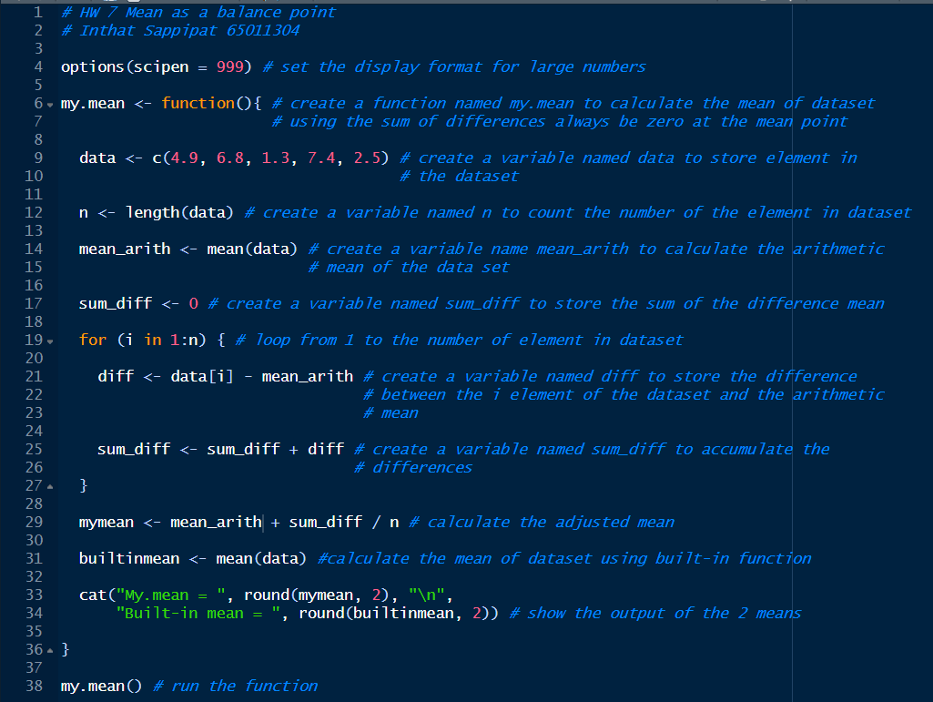**Code:**

**Result:**

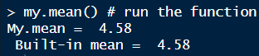

**Conclusion:**

From the experiment, my.mean is a function that demonstrates how to find the mean in the dataset using the sum of the difference always being zero at the mean point. The result of the function my.mean is the same as the result of the mean() built-in function which is 4.58. This confirms that the function my.mean that I have modified from the professor is consistent with the mean() built-in function.